Lab 4: Advanced Prompt Engineering – Zero-shot, One-shot, and Few-shot Techniques
NAME : SUMANTH AKARAPU
H.NO : 2303A52191
BATCH : 34
SUBJECT : AI ASSISTANT CODING
ASSIGNMENT: 4.2

Lab Objectives
• To explore and apply different levels of prompt examples in AI-assisted code generation.
• To understand how zero-shot, one-shot, and few-shot prompting affect AI output quality.
• To evaluate the impact of context richness and example quantity on AI performance.
• To build awareness of prompt strategy effectiveness for different problem types.

Lab Outcomes
• Use zero-shot prompting to instruct AI with minimal context.
• Use one-shot prompting with a single example to guide AI code generation.
• Apply few-shot prompting using multiple examples to improve AI responses.
• Compare AI outputs across the three prompting strategies.

Task 1 – Zero-shot Prompting
Prompt:
Write a Python function to determine whether a given number is prime.
Code:
def is_prime(n):
if n <= 1:
return False
for i in range(2, int(n**0.5) + 1):
if n % i == 0:
return False
return True
print(is_prime(7)) # True
print(is_prime(10)) # False
Explanation:
No examples were given, only the instruction. The AI generated a correct prime-checking function using logical conditions.
Expected Output:
True for prime numbers, False otherwise.
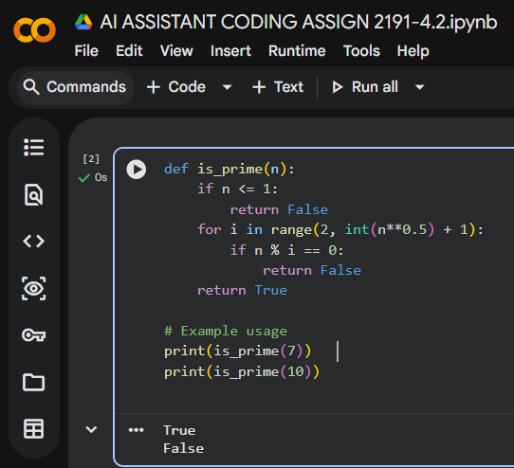

Task 2 – One-shot Prompting
Prompt:
Given Input: [1, 2, 3, 4], Output: 10. Write a Python function that calculates the sum of elements in a list.
Code:
def list_sum(numbers):
total = 0
for num in numbers:
total += num
return total
print(list_sum([1, 2, 3, 4])) # 10
Explanation:
A single example guided the AI to understand the task. The function correctly sums elements in a list.
Expected Output:
10 for [1,2,3,4].
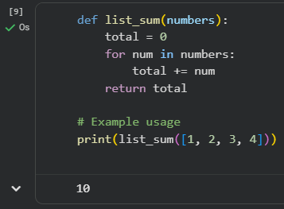

Task 3 – Few-shot Prompting
Prompt:
Input: "abc123" → Output: "123"
Input: "hello45world" → Output: "45"
Input: "noDigitsHere" → Output: ""
Code:
def extract_digits(s):
digits = ""
for char in s:
if char.isdigit():
digits += char
return digits
print(extract_digits("abc123")) # "123"
print(extract_digits("hello45world")) # "45"
print(extract_digits("noDigitsHere")) # ""
Explanation:
Multiple examples helped the AI generalize the rule: extract only digits.
Expected Output:
Correct digit-only strings.
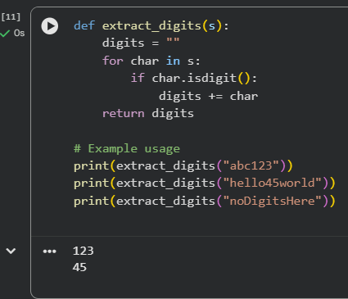

Task 4 – Zero-shot vs Few-shot Comparison
Zero-shot Prompt:
Write a Python function to count the number of vowels in a string.
Zero-shot Code:
def count_vowels(s):
vowels = "aeiouAEIOU"
count = 0
for char in s:
if char in vowels:
count += 1
return count
Few-shot Prompt with Examples:
Input: "hello" → Output: 2
Input: "world" → Output: 1
Input: "AEIOU" → Output: 5
Few-shot Code:
def count_vowels(s):
vowels = "aeiouAEIOU"
return sum(1 for char in s if char in vowels)
Comparison & Explanation:
Zero-shot: AI produced a correct solution but slightly verbose.
Few-shot: Examples helped AI refine the solution into a more concise version.
Impact: Few-shot prompting improves clarity and efficiency by showing patterns.
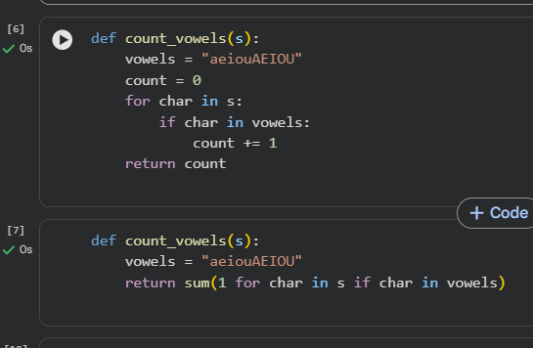

Task 5 – Few-shot Prompting (Minimum of Three Numbers)
Prompt:
Input: (3, 7, 5) → Output: 3
Input: (10, 2, 8) → Output: 2
Input: (6, 6, 9) → Output: 6
Code:
def find_min(a, b, c):
if a <= b and a <= c:
return a
elif b <= a and b <= c:
return b
else:
return c
print(find_min(3, 7, 5)) # 3
print(find_min(10, 2, 8)) # 2
print(find_min(6, 6, 9)) # 6
Explanation:
Few-shot examples guided AI to handle all cases without using min(). The function correctly determines the smallest of three numbers.
Expected Output:
Correct minimum values for all test cases.
